Contents

dfdd 1

# 20. Setting up the Base project for Library Event Kafka producer

1. 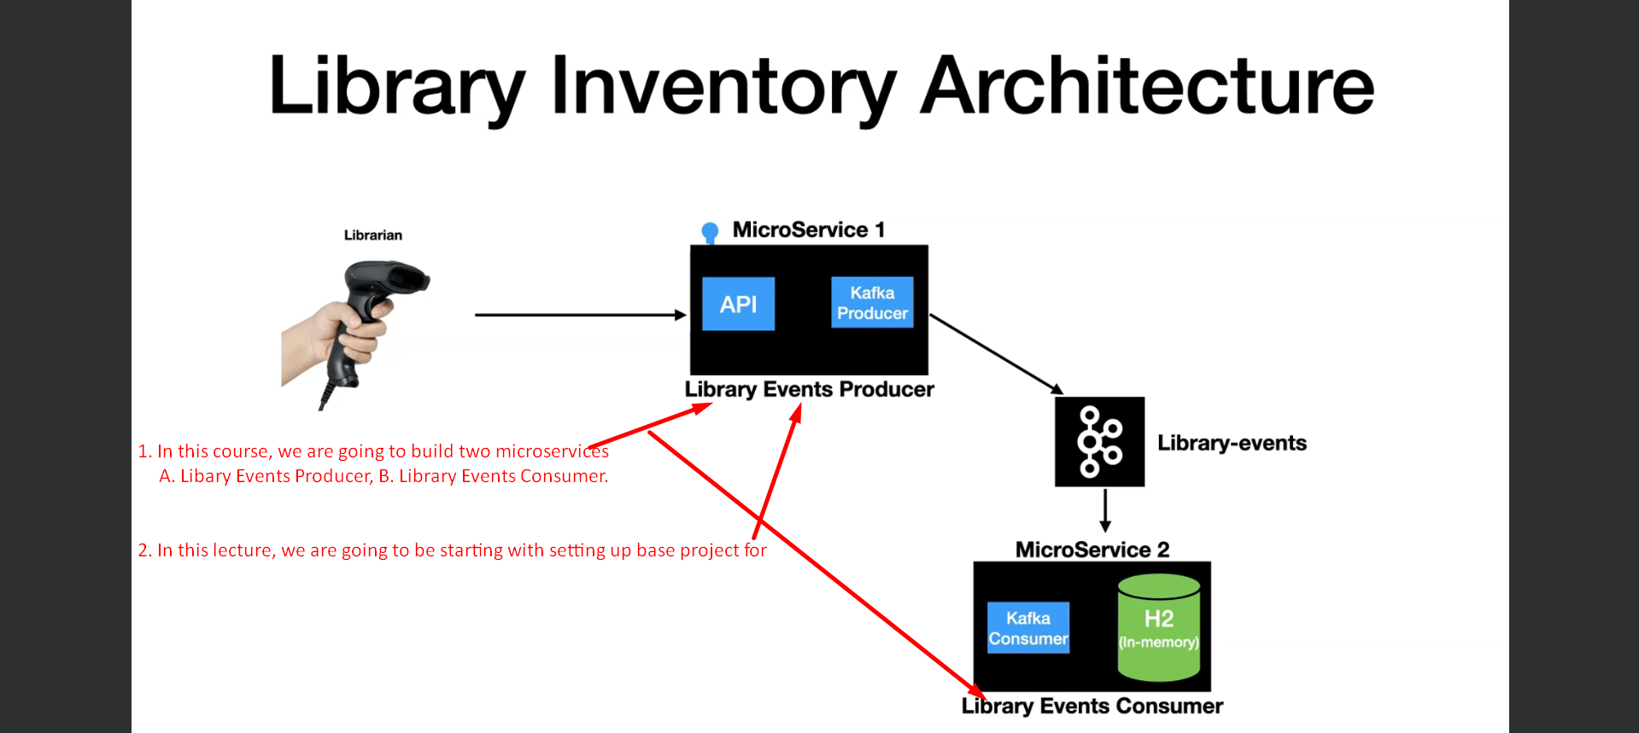
2. 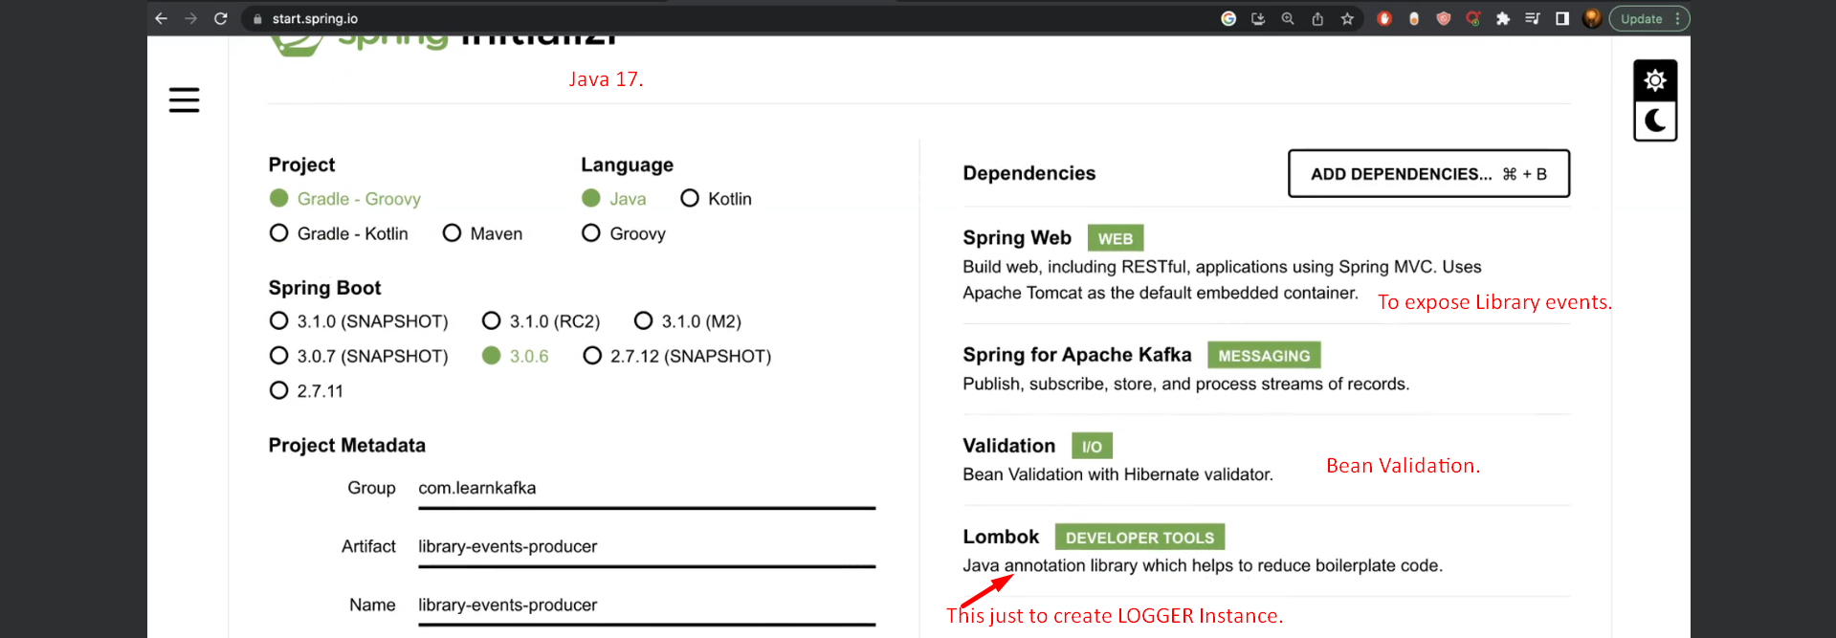
3. 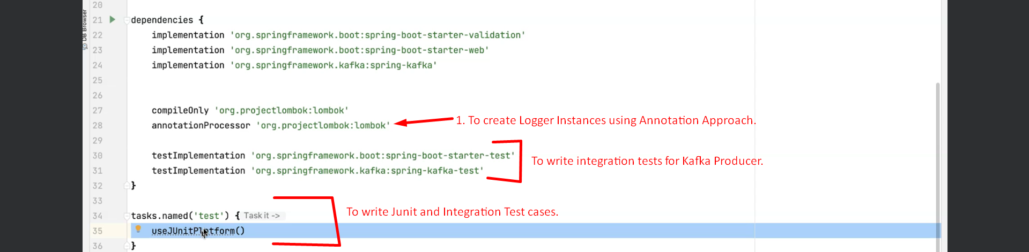

# 21. Build the Library Event Domain

# 23. Introduction to Spring KafkaTemplate to Produce Messages

1. Similar to JdbcTemplate.